Fashion Portfolio
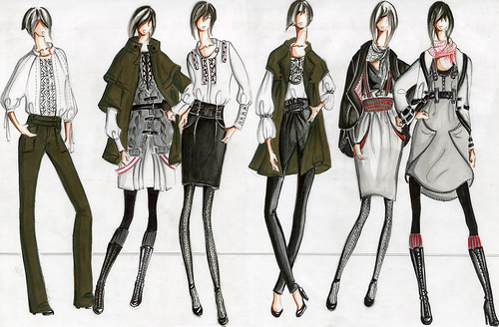

Jr. High Fashion Studies

Name ___________________________

Representation of fashions:

Objective: Using old books, magazines, or images gathered from the Web, represent the world of Fashion by selecting items that reflect your preferences in clothing, accessories, patterns, colors and fabric (you may also use fabric swatches if you like).

Part 1:
Provide a min. of 2 examples from three types of clothing lines (casual, business, formal, etc).
-You should have a total of 6 examples. (4 marks per example)
***To get full marks you must include accessories ***

Part 2:
Explain each selection choice, and your reasoning (Pattern coordination, color choice, trends,etc) (2 marks each)

Total Marks /36

Your Creative Flair

Scenario: As a current designer, you have just been asked to design an outfit (clothing AND accessories) for the top of the line fashion company, Vogue. They are requesting that you draw a sketch of your very own design so that it may be considered for the next runway show. The type of clothing line you choose is completely up to you!! (Formal, casual, business, etc)

What should be included:
Your design should not only display your clothing line choice, color choice, and pattern choice clearly, but it should also have a written response of why you have designed this particular outfit, and why you have chosen this particular clothing line (preference, trends, versatility, popularity, etc). In addition, why you chose the Fashion Career and what you love about it.

Design Sketch (Clothing and accessories) /5
Written response: (Why you designed this particular outfit, why you chose this clothing line, why you chose the Fashion career and what you love about the industry) /5

Total Marks /10

